Activity 1：Circle the keyword “让” and the person after 让 in the pictures below.

(Targeted skill-Identify parts of speech based on lexical and syntactic use)

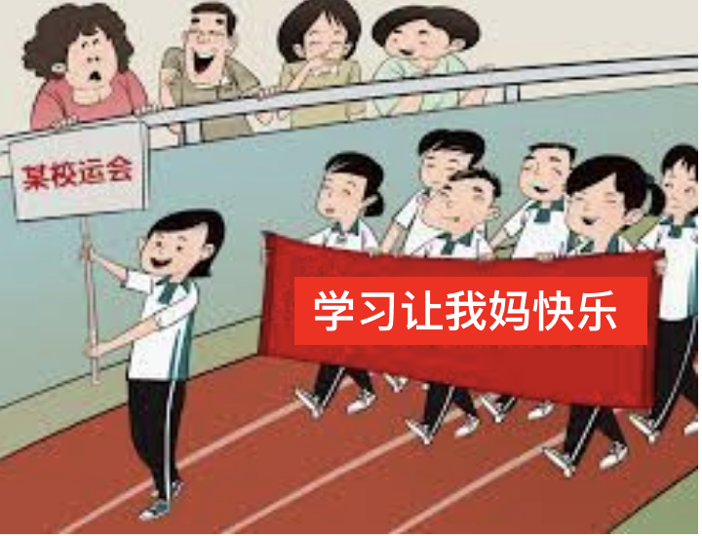

**学习让我妈快乐**

Activity 2：Use the corresponding colors to identify the word chunks in the sentences below.

(Targeted skill-parse a sentence into meaningful chunks)

运动让我快乐。

唱歌让王朋快乐。

Activity 3: Fill in the sentences below using the 让 pattern.